Date: 19-11-2019

**Tumor Types**

**Tumors**

* **Login Page**

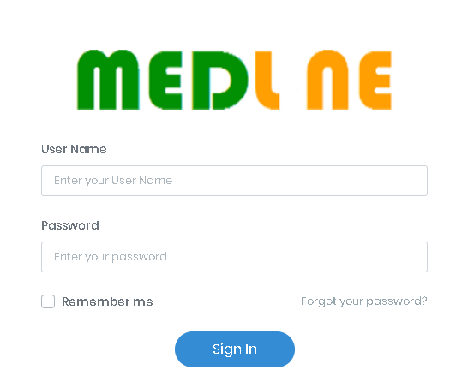

**Maintenance**

* **Create / Edit cancer type and its subtypes**

1. ICD code
2. Cancer type name

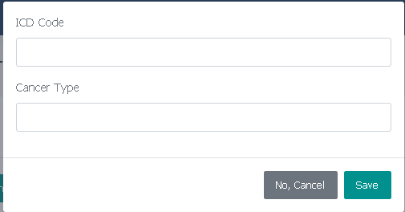

* **Show cancer type and subtypes**

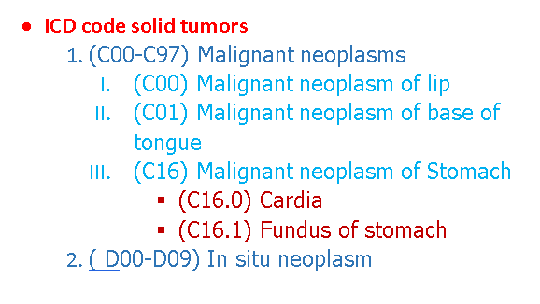

* **Create / Edit T:Tumor size or N:Lymph Node or M:Distant Metastasis**

1. Displayed name
2. Number
3. From
4. To
5. Description

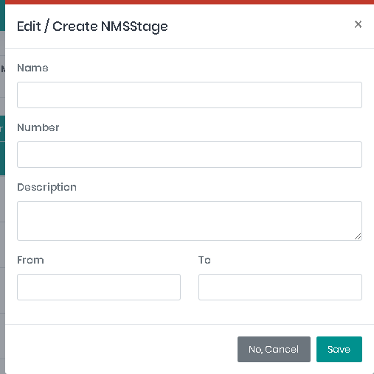

* **Show TNM**

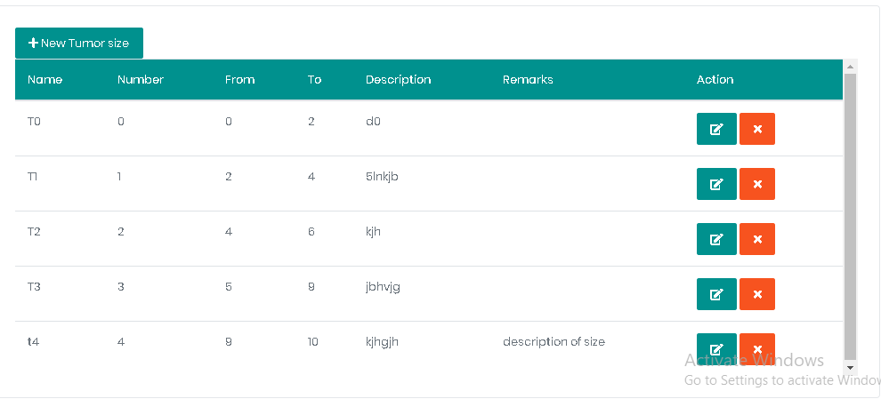

* **Create / Edit Stage**

1. Displayed name
2. Number
3. Remarks

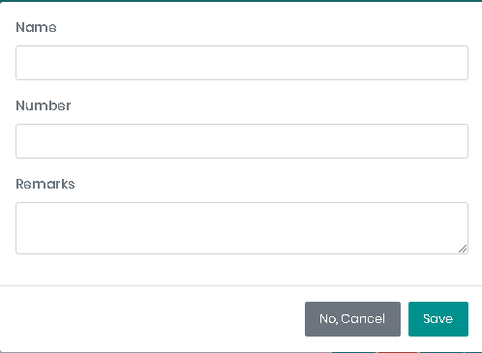

* **Show Stage List**

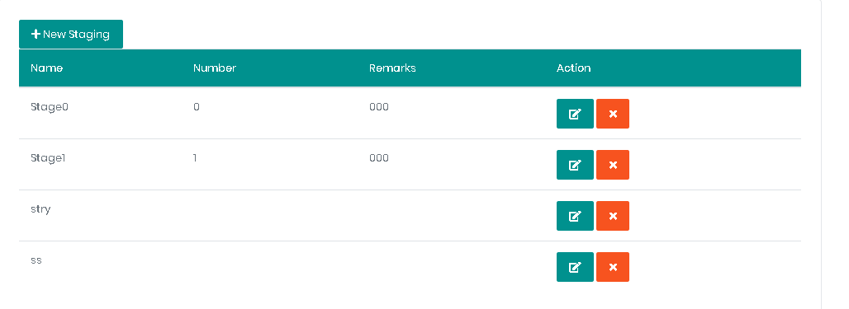

Hint: Each cancer type has list of histological cancer subtypes, list of molecular cancer subtypes, staging matrix, chemotherapy protocol. All of these you can edit and create and delete from any one as shown below:

* **Histological list**

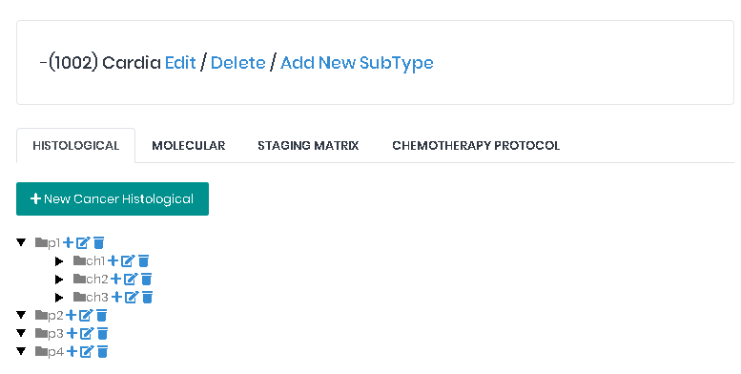

* **Edit/Create Histological cancer subtype**

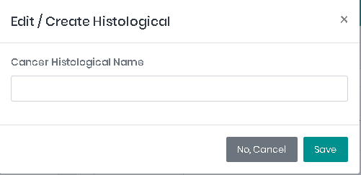

* **Molecular list**

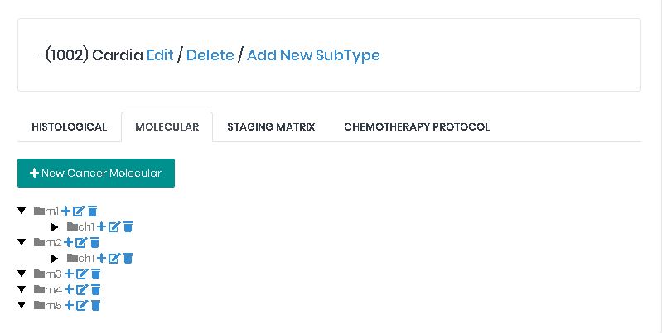

* **Edit/Create Molecular cancer subtype**

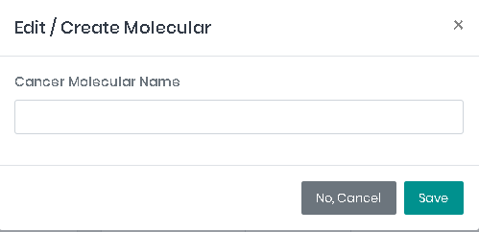

* **Staging matrix**

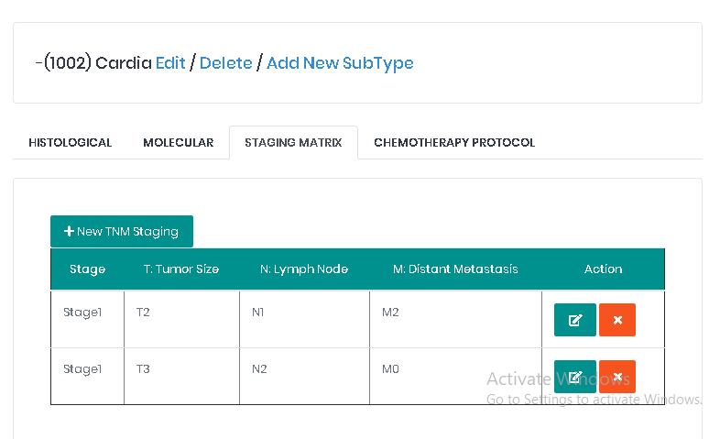

* **Assign T, N, M to stage**

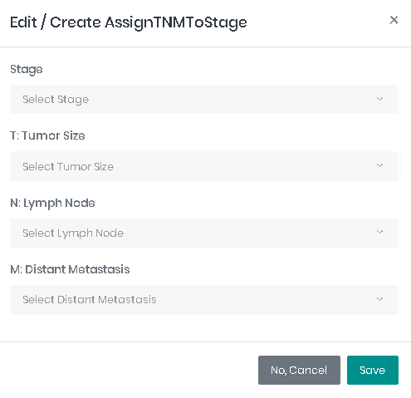

Hint: all T, N and M appear in these lists above (name with description) as shown below:

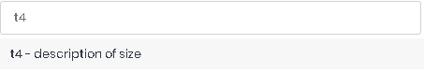

* **Chemotherapy protocol list**

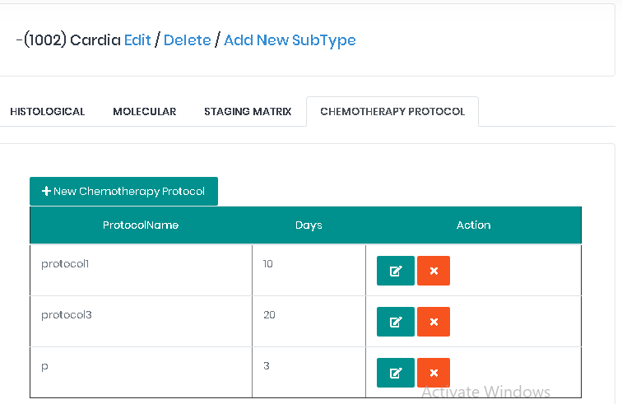

* **chemotherapy protocol**

1. Name
2. Days
3. Emetogenic risk (List 🡪 (high, low, moderate, minimal))
4. Growth factor (yes or no) if yes 🡪 add multiple drugs
5. Antimicrobial (yes or no) if yes 🡪 add multiple drugs
6. Premedication (List 🡪 will be added)

* **Drug data if protocol is growth factor or antimicrobial**

1. Drug name
2. Dose
3. Dose unit (List 🡪 body weight, adjust body weight, body surface area)
4. Route (List 🡪 IV, PO, SC, IM)

* **Drug for protocol**

1. Drug name
2. Dose
3. Dose unit (List 🡪 body weight, adjust body weight, body surface area)
4. Route (List 🡪 IV, PO, SC, IM)

If route is IV the rest of data will be as following:

1. Solution name
2. Solution amount
3. Final concentration
4. Duration (number)
5. Duration unit (List 🡪 minutes, hours, days, weeks)
6. Every (number)
7. Every unit (List 🡪 minutes, hours, days, weeks)
8. Days (check boxes from 1 to 28 to select days of this dose)

If route is PO the rest of data will be as following:

1. Special administration notes
2. Every (number)
3. Every unit (List 🡪 minutes, hours, days, weeks)
4. Days (check boxes from 1 to 28 to select days of this dose)

If route is SC the rest of data will be as following:

1. Duration (number)
2. Duration unit (List 🡪 minutes, hours, days, weeks)
3. Every (number)
4. Every unit (List 🡪 minutes, hours, days, weeks)
5. Days (check boxes from 1 to 28 to select days of this dose)

If route is IM the rest of data will be as following:

1. Solution name
2. Solution amount
3. Time of administration
4. Every (number)
5. Every unit (List 🡪 minutes, hours, days, weeks)
6. Days (check boxes from 1 to 28 to select days of this dose)

* **Create / Edit surgery type**

1. Type name

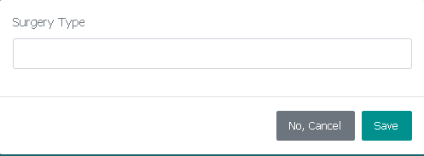

* **Show surgery types**

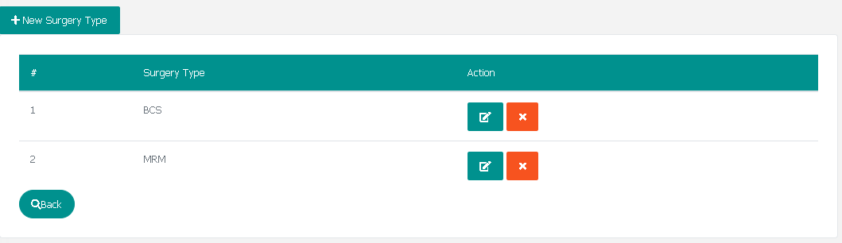

1. **Create / Edit treatment type**
2. Type name

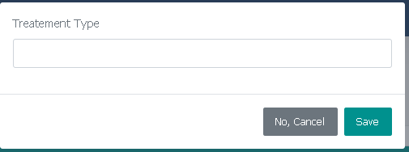

1. **Show treatement types**

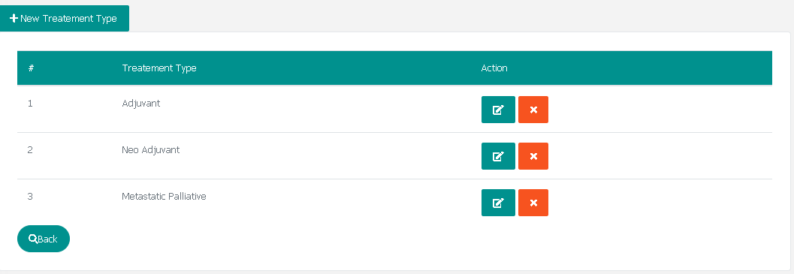

1. **Show imaging types**

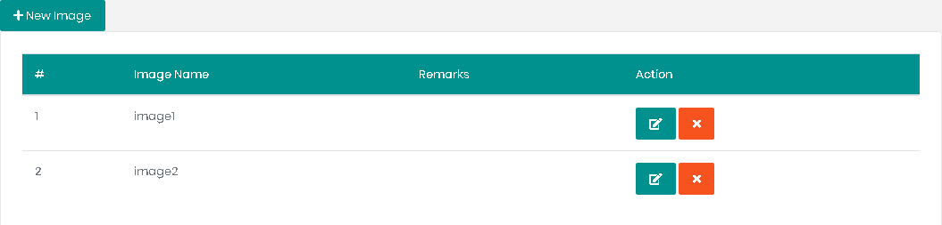

1. **Edit/Create image type**

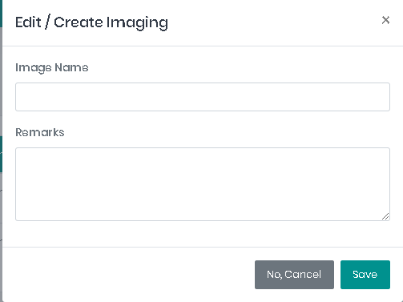

1. **Show Special Case list**

Ex: patient may be special case as pregnant and amputation (in parts of body)

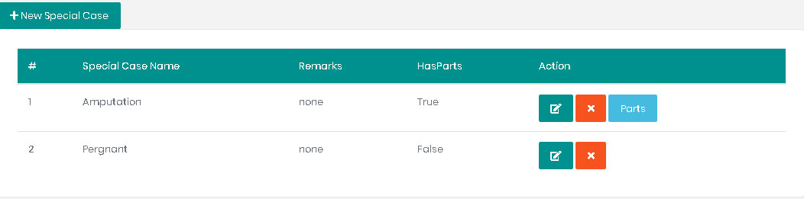

1. **Edit/Create special case**

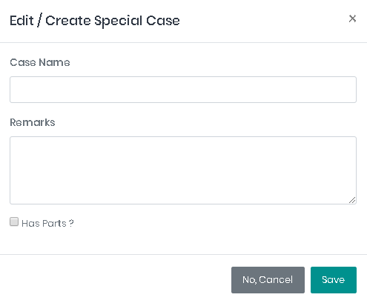

1. **Show parts of special case**

(If it has parts like amputation)

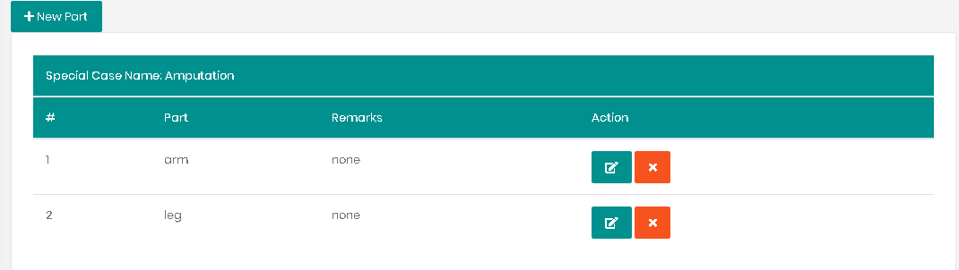

1. **Edit/Create parts for specific special case**

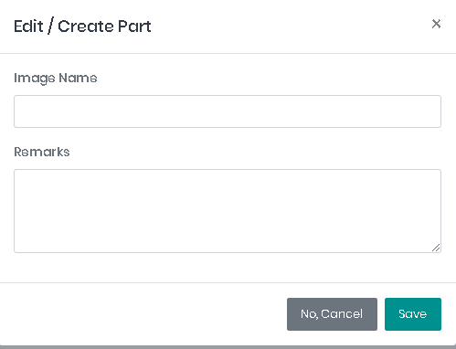

1. **Show main lab types**

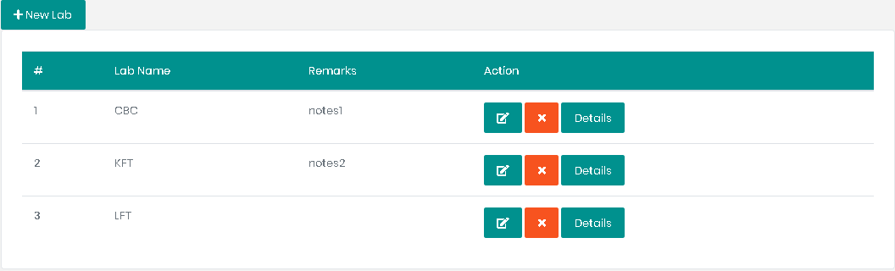

1. **Edit/Create lab type**

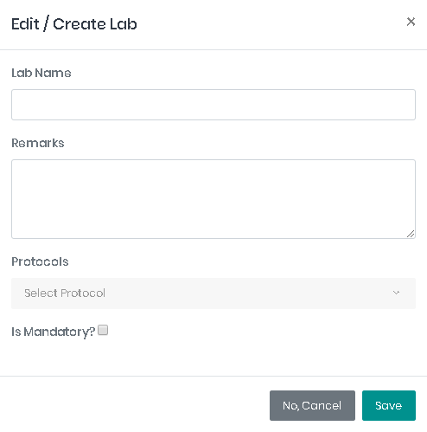

1. **Show sub lab types**

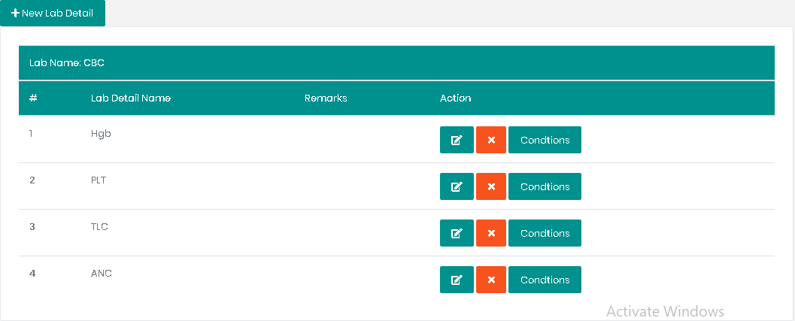

1. **Edit/Create sub lab type**

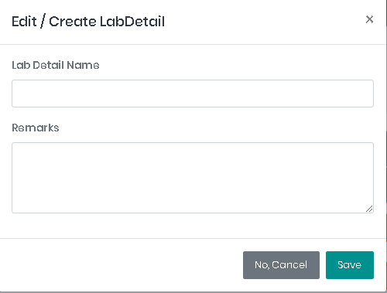

1. **Show sub lab conditions**

Ex: Hgb is more than 100 and less than 400

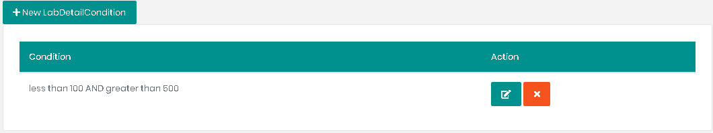

1. **Edit/Create sub lab condition**

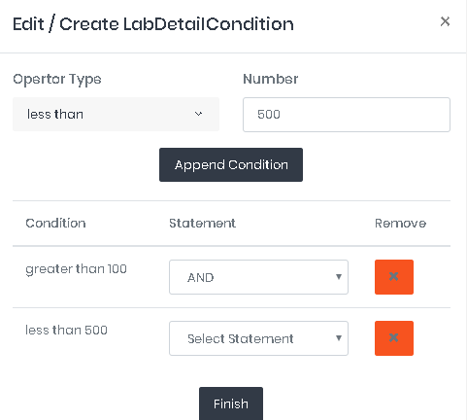

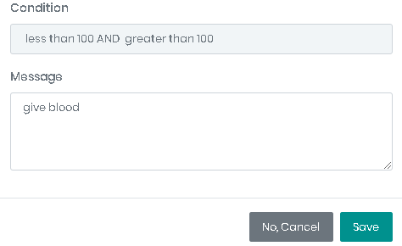

1. **Show all labs with their conditions**

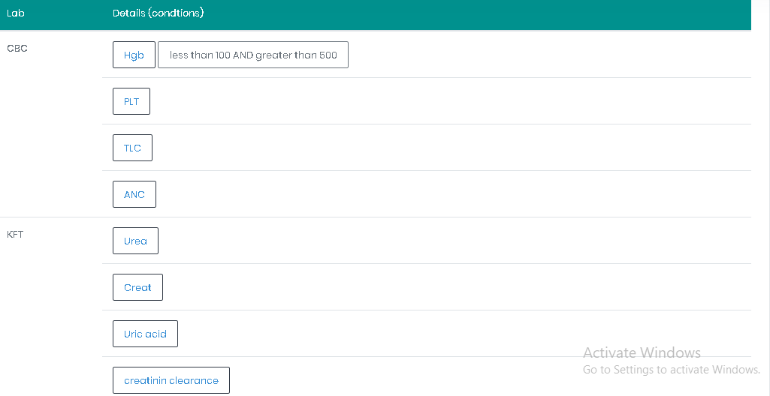

**Patient data and clinical data**

(Here use maintenance)

1. **Create / Edit patient data**
2. Full Name in Arabic and english
3. Number
4. Birthdate
5. Age
6. Gender
7. Residence
8. National ID
9. contact number
10. occupation
11. Payment method (Insurance, sponsoring company, direct payment) if select sponsor company text field will appear to insert company name
12. first visit date
13. care provider title
14. care provider name

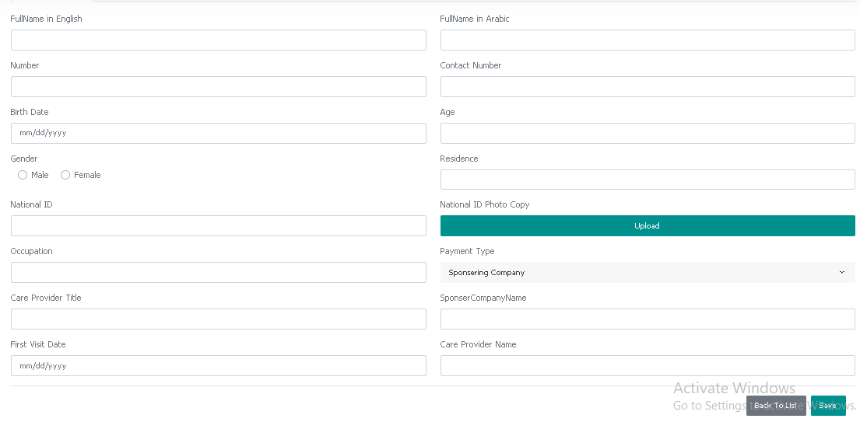

1. **show patient list**

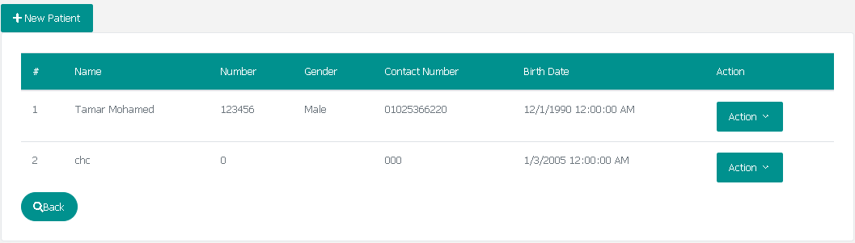

1. **show patient clinical data**

separated to 3 tabs (Diagnosis, Investigation, Surgery)

* **Diagnosis**

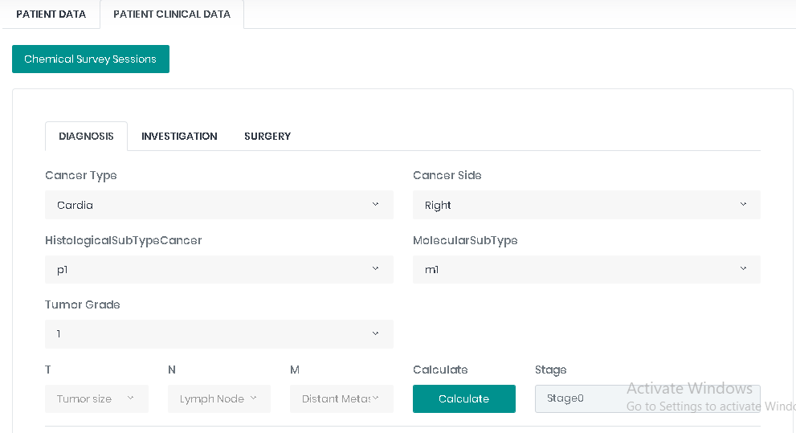

Hint: get stage according to T, N, M selected from staging matrix of selected cancer type

* **Investigation**

(include three parts imaging, lab, surgery)

* **Patient imaging**

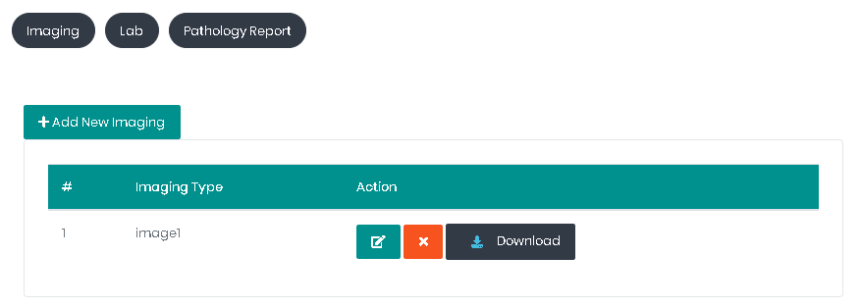

* **Edit/Create patient imaging**

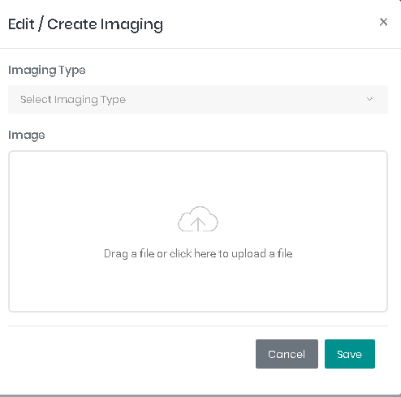

* **Patient labs**

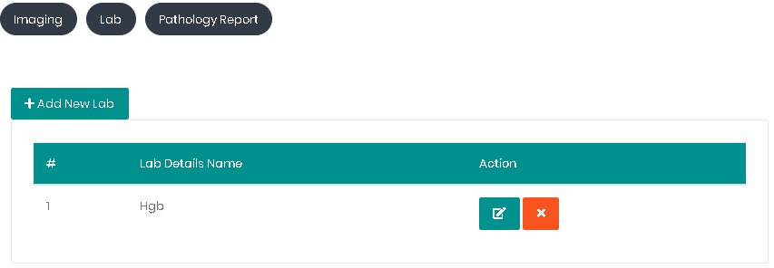

* **Edit/Create patient lab**

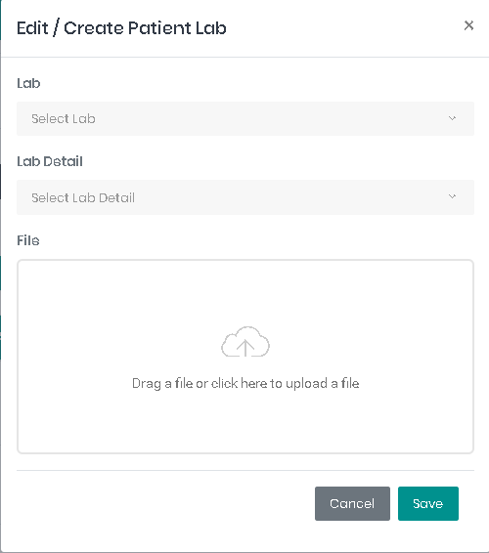

* **Patient pathology reports**

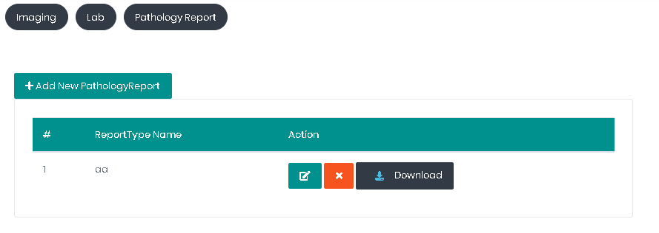

* **Edit/Create patient pathology report**

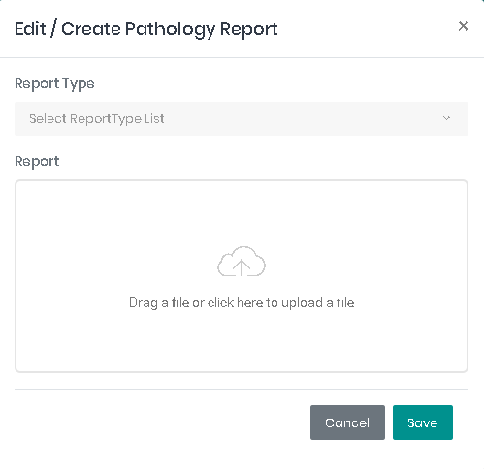

* **Create / Edit patient’s surgery**

1. Surgery type
2. Date of surgery

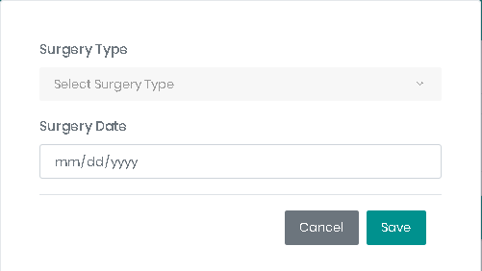

* 1. **Show patient’s surgeries**

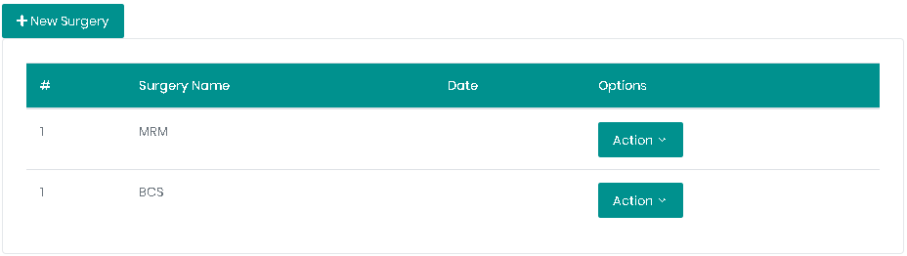

* **Patient chemical survey sessions**

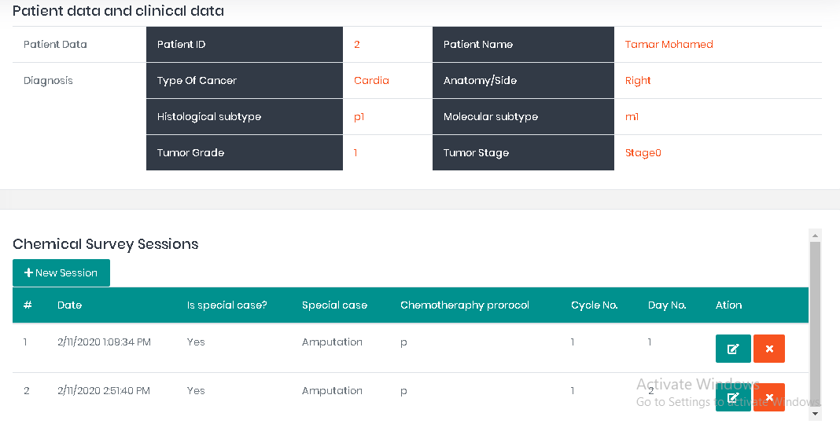

* **Edit/Create chemical survey session**

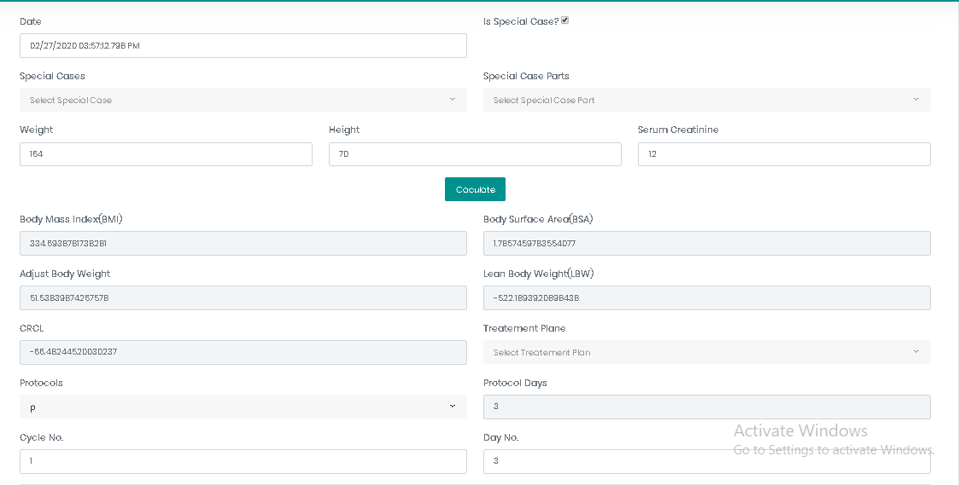

Hint:

- date is automatic (date time of now) and can be updated

- Cycle number and day is auto increment can be updated

- days of each cycle calculated from days of selected protocol

- Equations

